## Tableau Project: Global Financial Performance Analysis

**I. Project Goal and Key Analytical Questions**

The primary goal is to build a highly interactive Tableau dashboard that allows users to monitor and compare core financial metrics across key business dimensions.

**Key Analytical Questions:**

1. **Profitability Drivers:** Which **countries** and **products** generate the highest (and lowest) gross profit margins?
2. **Sales Effectiveness:** What is the sales trend over time, and how do **discount bands** influence overall gross sales volume?
3. **Cost Efficiency:** What is the relationship between **COGS** (Cost of Goods Sold) and **Sales** across different **Segments**?
4. **Market Performance:** Which **Segment/Country** combinations offer the greatest growth opportunity based on historical sales and profit growth rates?

**II. Data Preparation and Cleaning (Tableau Prep/Data Pane)**

Successful visualization hinges on clean data. Since initial inspection revealed that most financial columns are stored as text (due to currency symbols and commas), the following transformations are critical:

1. **Column Renaming:** Remove leading/trailing spaces from column headers (e.g., rename Product to Product, Sales to Sales).
2. **Data Type Conversion:** Convert all financial columns (Units Sold, Manufacturing Price, Sale Price, Gross Sales, Discounts, Sales, COGS, Profit) from **String/Object to Decimal Number**. This requires:
   * **Removing all '$' symbols and ',' commas.**
   * **Handling negative values** (e.g., $(40,617.50)) by replacing parentheses () with a negative sign (-).
3. **Date Field:** Ensure the **Date** column is correctly formatted as a **Date** type for accurate time-series analysis.
4. **Creating Calculated Fields:** Define essential profitability metrics within Tableau:
   * **Gross Margin %:** (Profit/Sales)×100

**III. Dashboard Structure and Key Visualizations**

The final dashboard will be organized into three logical tabs or sections for layered analysis:

**A. Executive Summary (The Big Picture)**

| Visualization | Data Fields | Purpose |
| --- | --- | --- |
| **KPI Scorecards** | Total Sales, Total Profit, Average Gross Margin % | Provide **at-a-glance** metrics for quick performance assessment. |
| **Sales Trend Over Time** | Line Chart: Sales (Y-Axis) vs. Date (X-Axis) | Visualize historical growth, seasonality, and overall sales momentum. |
| **Profitability Map** | Filled Map: Color-coded by Average **Gross Margin %** by **Country** | Instantly identify the most and least profitable geographic markets. |

**B. Profit & Cost Drivers**

| Visualization | Data Fields | Purpose |
| --- | --- | --- |
| **Top/Bottom N Analysis** | Bar Chart: Profit by **Product** | Show the top 10 products contributing the most (and least) to total profit. |
| **Efficiency Scatter Plot** | Scatter Plot: COGS (Y) vs. Sales (X), colored by **Segment** | Assess cost efficiency. Points above the trend line are less efficient; points below are more profitable per sale dollar. |
| **Discount Impact** | Tree map /Bar Chart: Gross Sales by **Discount Band** | Quantify the revenue generated under each discount category to evaluate pricing strategy effectiveness. |

**C. Market Deep Dive**

| Visualization | Data Fields | Purpose |
| --- | --- | --- |
| **Cross-Tab Table** | Segment, Country, Sales, Profit, Gross Margin % | Allow users to quickly drill down into the raw numbers for granular analysis. |
| **Filters** | Global Filters for **Country**, **Product**, **Year**, and **Segment** | Enable users to customize the view and focus the analysis on specific market niches. |

**Dash Board**

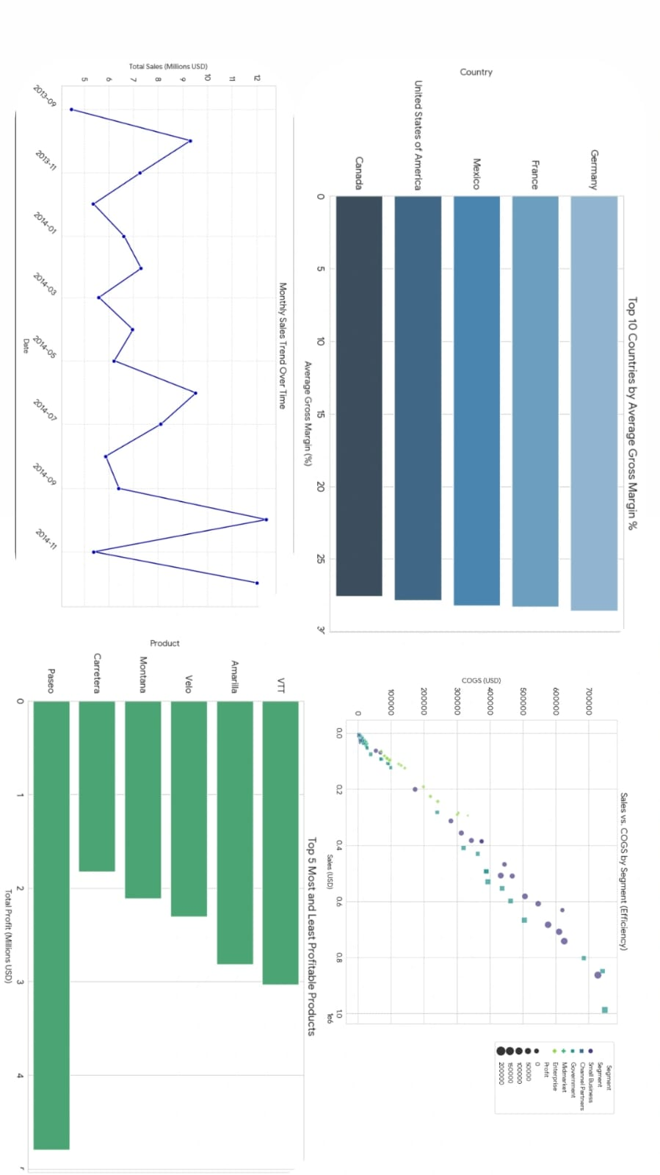

**IV. Conclusion**

The Tableau dashboard will empower decision-makers to shift from reactive reporting to **proactive strategic planning**. By easily identifying high-margin products, highly profitable market segments, and the financial impact of discounting policies, the business can make data-driven decisions on product focus, pricing strategy, and resource allocation.